Mask-Burkina Faso-Mossi

Mossi Mask

Origin: Burkina Faso  
Size : 42.519 inches x 9.05 inches  
Weight: 4.493 pounds  
Material: wood

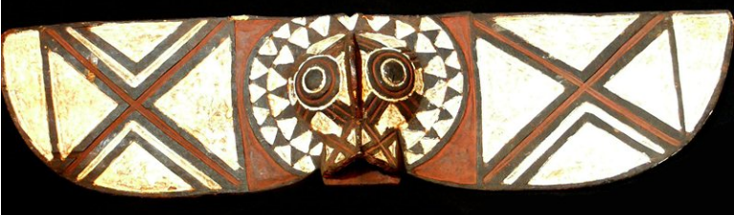 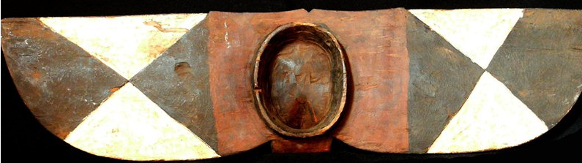

**The Yatenga Style**The geographical area in which the Yatenga style masks are concentrated is the section of Mossi country to the north of the low,   
swampy area around Nyessega and the Kourougui River, which flows west to east halfway between Yako and Gourcy, and to the   
west of the border between Yatenga and the kingdoms of Zitenga and Risiam. This is the general area of the Mossi kingdom of   
Yatenga (see map).  
  
The range of this Yatenga style also extends to a few scattered villages to the southwest of the White Volta-the region of the   
Ouagadougou stylewhere the tall Yatenga style masks are found in and are dominated by the Ouagadougou style. Throughout   
the Ouagadougou style area Yatenga style masks are rather rare, while the small zoomorphic masks are ubiquitous. The two mask   
styles must never dance in the same area at the same time, and if, on their way to a funeral, the two meet on a bush path, the   
small masks flee into the bush. With the exceptions of the Ninisi villages of Kaséba, Moundia, and Tarmounouma in the southwest   
corner of the area, no Ouagadougou style masks are found in Yatenga.  
  
Yatenga style masks have been cited as most characteristic of the Mossi style in all publications to the present. They are vertically   
oriented, worn over the face, and consist of a round or oval facial area surmounted by a tall, thin, wooden plank, often a meter or   
a meter and a half long, with a very small antelope head and long horns rising above the mask face just in front of the plank. In the   
great majority of examples the antelope horns are not attached directly to the facial area of the mask but come together to form a   
very small triangle, often colored white, which forms the head of the antelope. As in the rest of Mossi country, masks are called   
wango. However, Yatenga style masks with oval faces, planks, and antelope horns may also be referred to by the more specific   
name karanga.  
  
A second important mask type in the same style is distinguished by the addition of a wooden female figure above the face of the   
mask and either in front of the plank or entirely replacing. The female figure is called wemba and all such masks are called   
karanwemba. Karansé and karan-wemba are worn with a costume consisting of a traditional Mossi shirt and trousers, a lightly   
fringed fiber skirt tied around the waist, and a cloth or fiber cap which helps to bind the mask to the wearer's head. The costume   
hides the identity of the wearer but no attempt is made to conceal the fact that the mask is worn by a human, in contrast to the   
very heavy fiber costumes worn with masks in the southwest and in the far eastern regions of Mossi country.  
The concave face of the Yatenga style mask is painted white with chalk or lizard excrement mixed with egg. Geometric designs   
which are carved into the surface of the plank are outlined in white, alternating with areas painted earth-red with ground hematite   
stone. The spiral marks on the horns and other areas are blackened by burning with hot pokers and then glazed with melted   
vegetable resin (gum arabic).  
  
The karansé in each village are owned by individual Nyonyosé clans and are in no way under the supervision of the earth-priest.   
The senior male clan member appoints a young man of the family to wear the mask at funerals. There is no organized, exclusive   
male mask society or group such as the "Wango Society" which has been frequently referred to by catalogers of western   
collections.  
  
Yatenga style Mossi masks are stylistically related to certain vertical, plank-topped Dogon masks. The Nyonyose in Yatenga who   
produce masks are remnants of the Dogon occupation of the area to about 1500. Most Dogon fled northwest to the cliffs of the   
Bandiagara escarpment before the Nakomsé cavalry, and those who remained behind were integrated into Mossi society. The   
styles of the two groups have developed independently in the intervening 500 years, so that it is now possible to distinguish   
between them. Masks in both styles have concave faces and triangular eyes, bisected by a vertical ridge. Dogon masks are   
rectangular and Mossi masks are oval.  
  
Source: http://artqtserver.art.uiowa.edu:8080/Mask_styles/Index.html

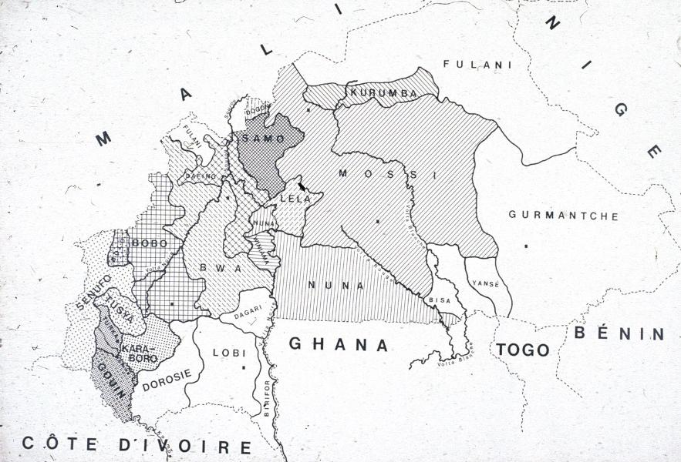

MOSSI (MOLE, MOOSE, MOSI)  
  
Burkina Faso  
  
The first Mossi Empire was founded by invaders from northern Ghana. Today, the Mossi are the largest tribe living in Burkina Faso. They   
number 2,2 to 3,5 million and are the only tribe of Inland West Africa to have a centralized governing body, in addition to clans and   
professional corporations led by elders known as zaksoba. They are an ethnically diverse people divided into two social groups. Political   
power resides in nakomze, whose ancestors invaded the region in 15th century and subjected the various autochthonous groups living   
there. From these arose the tengabisi, a heterogeneous population whose kinship groups have provided the religious leaders of the   
Mossi to this day. On the north, one encounters a region of Sahelian desert steppes, then further south a zone of tree-field savannas,   
which gives way to forestland in the deep south. The greater part of the population lives off agriculture and cattle breeding. They grow   
millet, sorghum, maize, sesame, peanuts, and indigo. Cotton, introduced by the French during the occupation, is also cultivated over large   
stretches of land. Since the beginning of the century, the family has not been regarded as part of a community, since custom required   
that, immediately after circumcision, the eldest son leave to live independently from his father. Similarly, the young wife had no status   
whatsoever until the birth of her first child, which gave her the right to visit her parents. She did not raise her children, who were entrusted   
to older wives. On the other hand, at the death of a farther, the son would receive the wives and fields of his father.  
  
The blacksmiths-sculptors formed a separate caste and lived in separate quarters; they married exclusively within the caste. They were   
feared by their neighbors and participated actively in rituals. They made jewelry, metal and wood sculpture, statues, and masks. Brass   
figures and wooden ancestor figures are controlled by the Mossi ruling elite. Maintaining good relations with the ancestors and a variety of   
supernatural forces is a major concern of Mossi ritual and motivates art production in the region. Figures are used by the ruling class to   
validate political power, and masks are used by the conquered peoples to honor the spirits of the wilderness and control the forces of   
nature. The aristocracy used statues, even though it had adopted Islam in the seventeenth century. For the most part female, linked to   
the power of the chiefs, these figures commemorated ancestors and were kept inside the hut of the oldest of the wives. They appeared   
only at the funeral of the sovereign and at the time of the annual sacrifice when the first fruit of the harvest would be offered.    
  
Lineages and clans of the indigenous tengabisi inhabitants own the masks, and only the large group of farmers and the group of smiths   
employ a variety of masks. Mossi sculptors are mostly famous for their polychrome masks. The farmers, “children of the earth” and   
descendants of the autochthones, still use huge masks; formerly, these masks were regarded as the seat of the spirit, but they might also   
represent the totemic animal of the clan. Each family would refer to an appropriate myth explaining the mask’s origin: generally, it was   
most often a catastrophe that had brought a sacred animal, or even a god, to make a gift of a mask to an ancestor, the power of mask   
allowing the restoration of order within the clan; then, too, at the ancestor’s death the mask would become the material structure of his   
soul. These masks made their appearance several times during the course of the year: they would escort the dead, thus helping them to   
join the world beyond. They preside over the sacrifices offered at the beginning of the rainy season, which were to insure the community a   
good millet crop and harvest of wild fruits. They “supervised,” before the first harvest, the deference given to planted seeds   
corresponding to a period of famine. Between “appearances,” the masks remained on the family shrine, where they received prayers and   
sacrifices for those members of the family who were in need, and they aided communication with the ancestors. The mask types evince   
regional differences.  
  
The blacksmiths also used to sculpt figures called biiga, often covered in leather and decorated with cowrie shells and beads. The   
function of these wooden “dolls” goes well beyond game-playing. As an educational toy, the biiga was dressed, washed, and carried on   
the back or placed on the ground under the mother’s eyes. The biiga has a complex symbolism that, at first glance, seems contradictory:   
for the little girl it is, at one and the same time, the power that will cause her to have a child and the baby she is learning to care for. The   
biiga passes from mother to daughter or from sister to sister. Biiga have cylindrical bases; arms and legs are missing, but the pendulous   
breasts, symbol of motherhood, are accentuated.     
Source: www.zyama.com